1. What is JavaScript?

**Module:6 JavaScript Basic &Dom**

* JavaScript is a scripting or programming language that allows you to implement complex features on web pages

1. What is the use of isNaN function?

* The isNaN() function determines whether a value is NaN when converted to a number. Because coercion inside the isNaN() function can be surprising, you may alternatively want to use Number.isNaN() .

1. What is negative Infinity?

* NEGATIVE_INFINITY is a special numeric value that is returned when an arithmetic operation or mathematical function generates a negative value greater than the largest representable number in JavaScript

1. Which company developed JavaScript?

* JavaScript was invented by Brendan Eich in 1995. It was developed for Netscape 2, and became the ECMA-262 standard in 1997

1. What are undeclared and undefined variables?

* Undeclared variables are those that have not been declared or defined in the current scope, while undefined variables are those that have been declared but not given a value.

1. Write the code for adding new elements dynamically?

* The createElement() method in JavaScript can be used to create new items dynamically. The setAttribute() method is used to set the attributes of the newly generated element.

1. What is the difference between ViewState and SessionState?

* Session state is saved on the server, ViewState is saved in the page.

1. What is === operator?

* The strict equality ( === ) operator checks whether its two operands are equal, returning a Boolean result.

1. How can the style/class of an element be changed?

* document. getElementById("MyElement"). className = "MyClass"; (You can use a space-delimited list to apply multiple classes.)

1. How to read and write a file using JavaScript?

* file=fopen(getScriptPath(),0); The function fread() is used for reading the file content.
* str = fread(file,flength(file) ; The function fwrite() is used to write the contents to the file.
* file = fopen("c:\MyFile.txt", 3);// opens the file for writing.

1. What are all the looping structures in JavaScript?

* for - loops through a block of code a number of times.
* for/in - loops through the properties of an object.
* for/of - loops through the values of an iterable object.
* while - loops through a block of code while a specified condition is true.

1. How can you convert the string of any base to an integer in JavaScript?

* To convert a string to an integer parseInt(), Number(), and Unary operator(+) function is used in javascript. parseInt() function returns Nan( not a number) when the string doesn't contain number.

1. What is the function of the delete operator?

* The delete operator removes a property from an object. If the property's value is an object and there are no more references to the object, the object held by that property is eventually released automatically.

1. What are all the types of Pop up boxes available in JavaScript?

* JavaScript has three kind of popup boxes: Alert box, Confirm box, and Prompt box.

1. What is the use of Void (0)?

* JavaScript void 0 means returning undefined (void) as a primitive value. You might come across the term “JavaScript:void(0)” while going through HTML documents. It is used to prevent any side effects caused while inserting an expression in a web page.

1. How can a page be forced to load another page in JavaScript?

* In JavaScript, we can use window. location object to force a page to load another page. We can use the location object to set the URL of a new page.

1. What are the disadvantages of using innerHTML in JavaScript?

* Event handlers attached to any DOM element are preserved.
* Replacement is done everywhere.
* It is not possible to append innerHTML.
* Breaks the document.
* Used for Cross-site Scripting.

1. Create password field with show hide functionalities

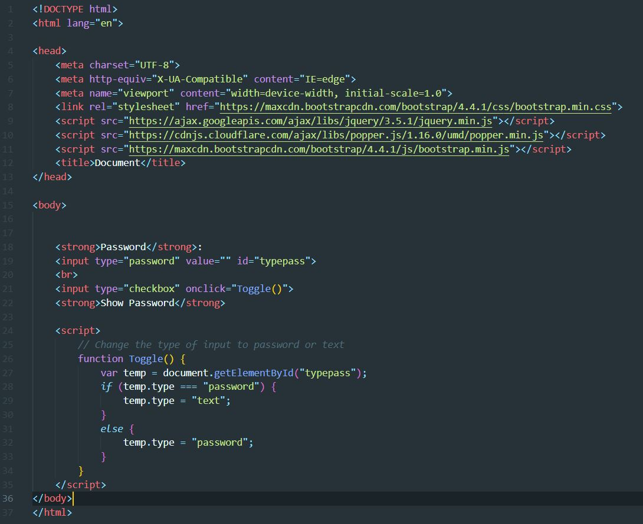

* Output

